LIBRARY MANAGEMENT
SYSTEM
******
Installation Guide

1.Open SQL Server 2005, enter login name and password to login system of SQL Server 2005
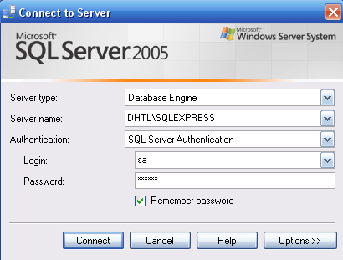

You have to attach database by click to Attach…
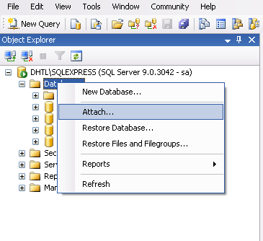

Then click Add, after that you choose the location to the LibraryManagementSystem.mdf then click to OK.

Then click Add, after that you choose the location to the LibraryManagementSystem.mdf then click to OK.

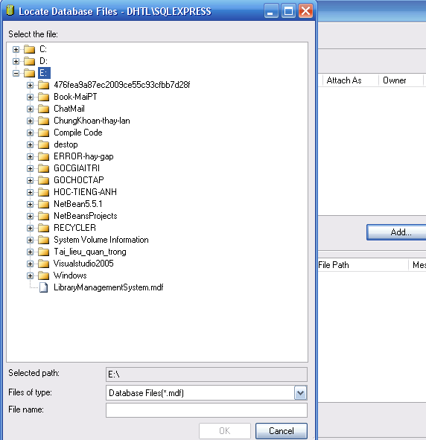

Once done, it means you attach database successfully.

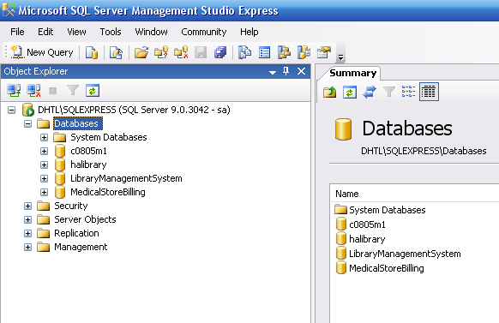

Notes :
You have to save these files and folder in the same folder with Me LibraryManagementSystem.jar
- The Lib folder contain files : AbsoluteLayout.jar,jcalendar-1.3.2.jar,JTattoo.jar,sqljdbc.jar
- The file : ConnectionConfig.properties,Help.chm
If these files and folders lost, the program can’t be run!

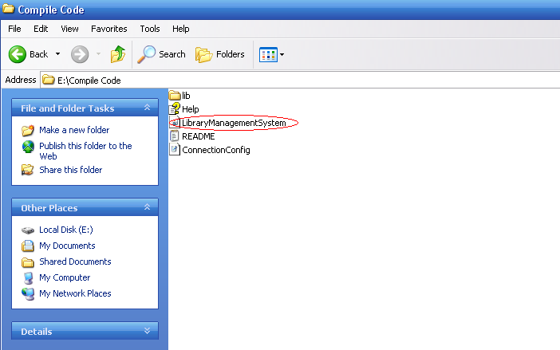

After attaching the database successful you run the application LibraryManagementSystem.jar

The Login form will appear.Then you type Username is :’vuducha’ ,Password : ‘1234567’ to login to User System
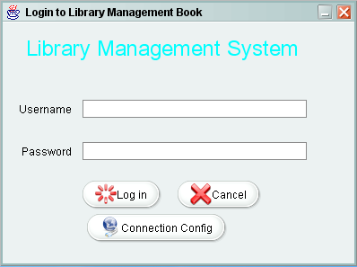
In the first login you have to change the Connection config for system by click ‘Connection Config’
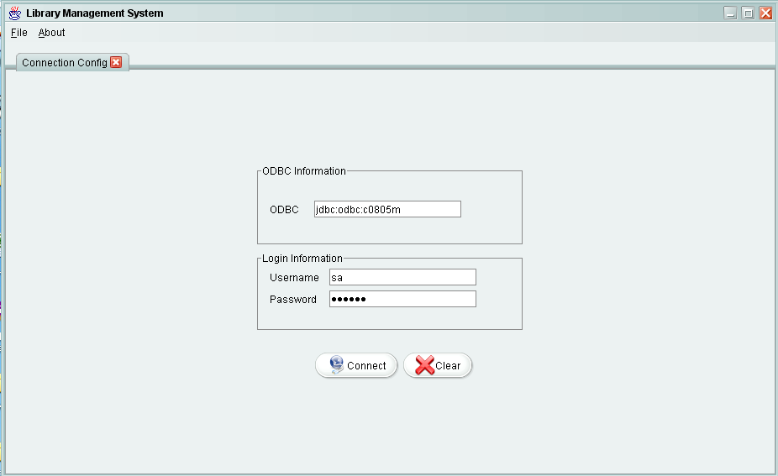
Then you have to type ODBC,and username ,password to login to SQL Server ,click ‘Connect’ button to connect .If the connection is successful the login form will appear again and you have to type Username an password.
You have to enable you ODBC

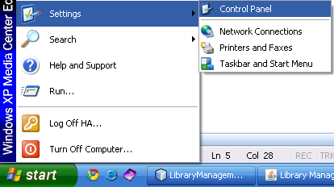
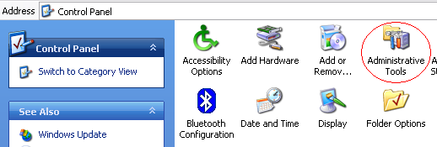

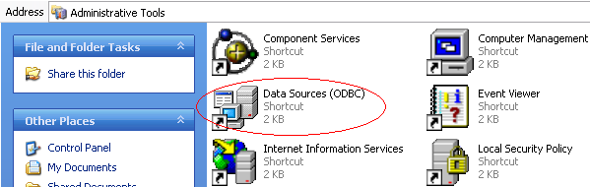
Then set Enable for ODBC
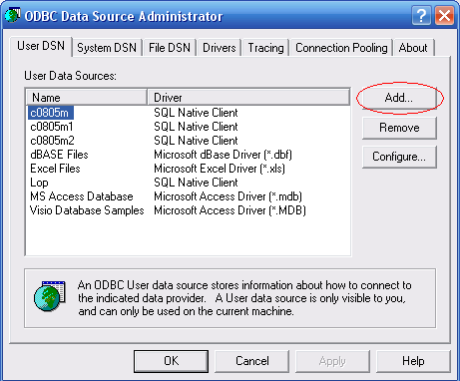
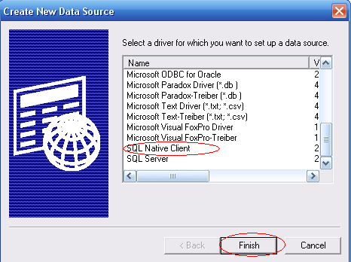
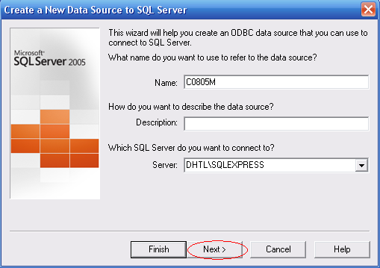

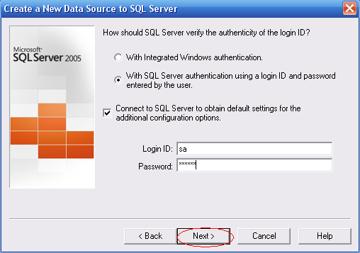
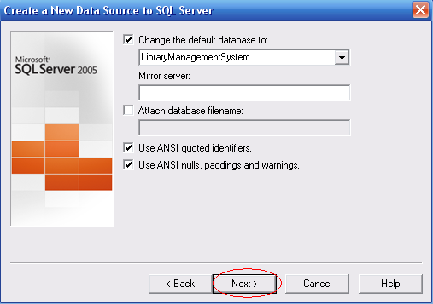

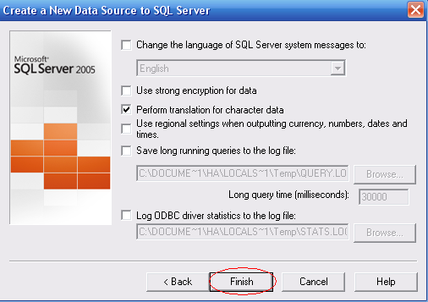
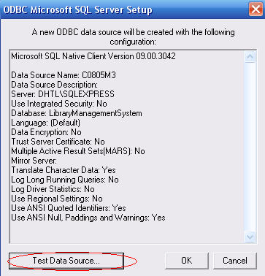

After Logging on to application successfully, you logon as User the tasks for User will be displayed with the application.
